**Wilson, Alex**

**CS214 – Database Technologies**

**HOP NUMBER 10**

**Part 1**

**SCREENSHOT #1**

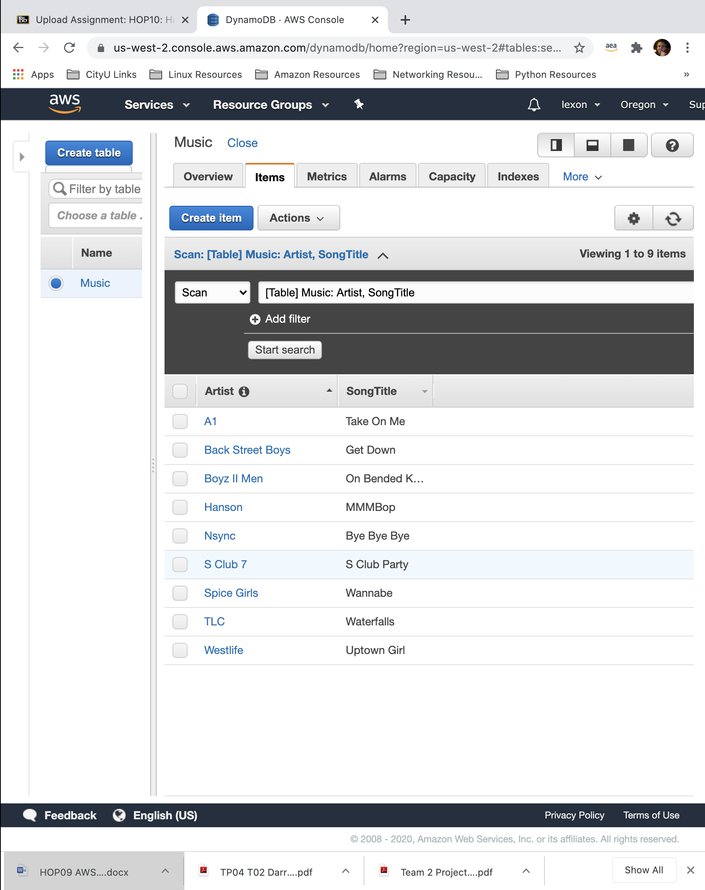

**SCREENSHOT #2**

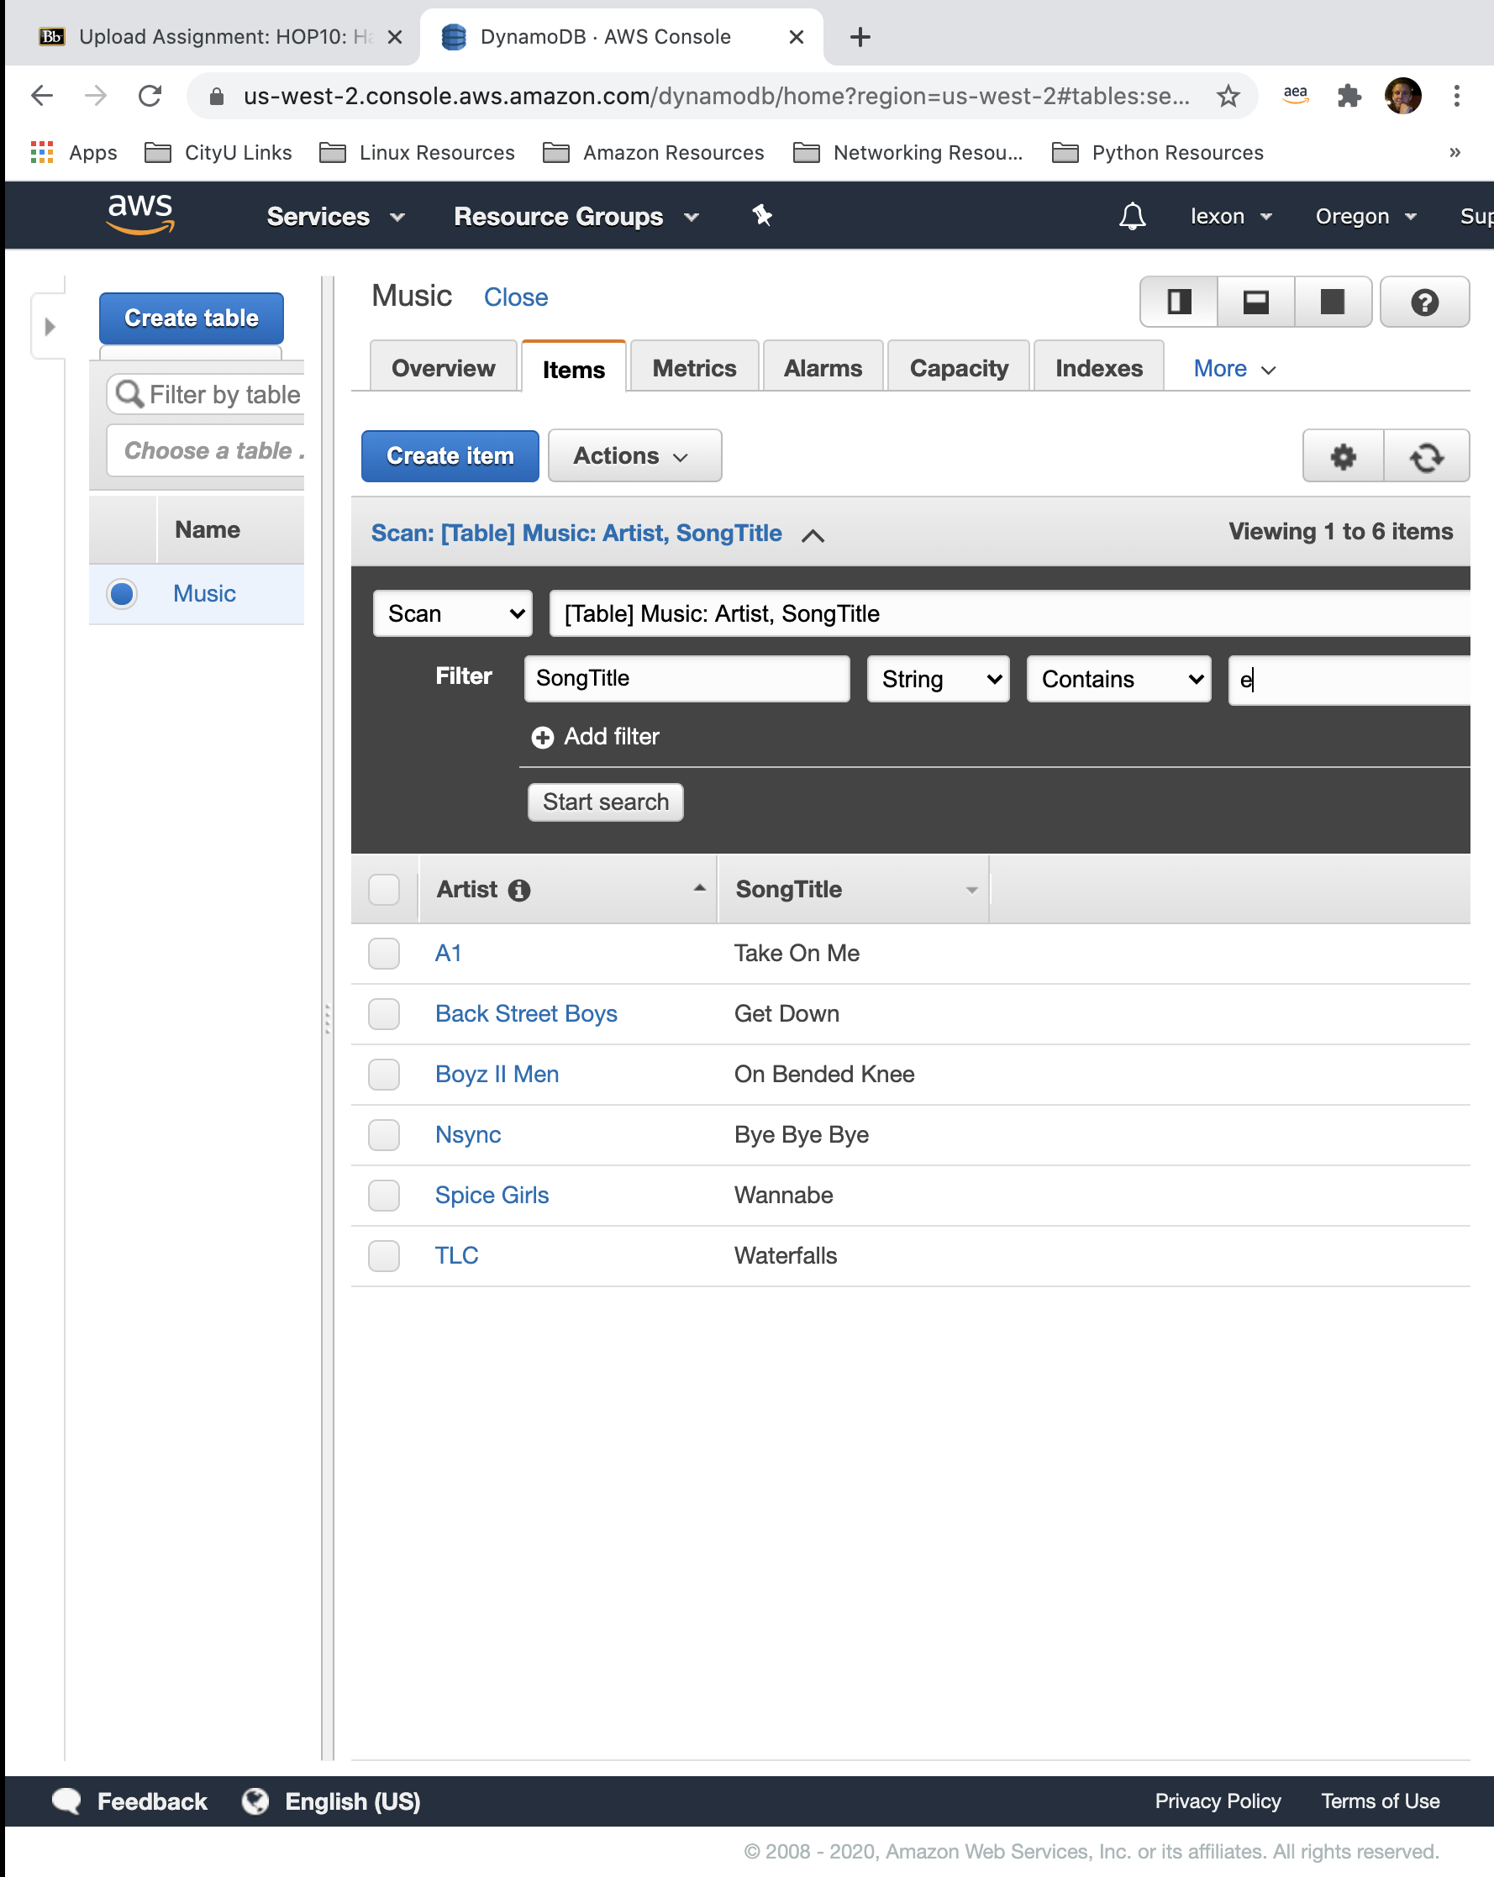

**SCREENSHOT #3**

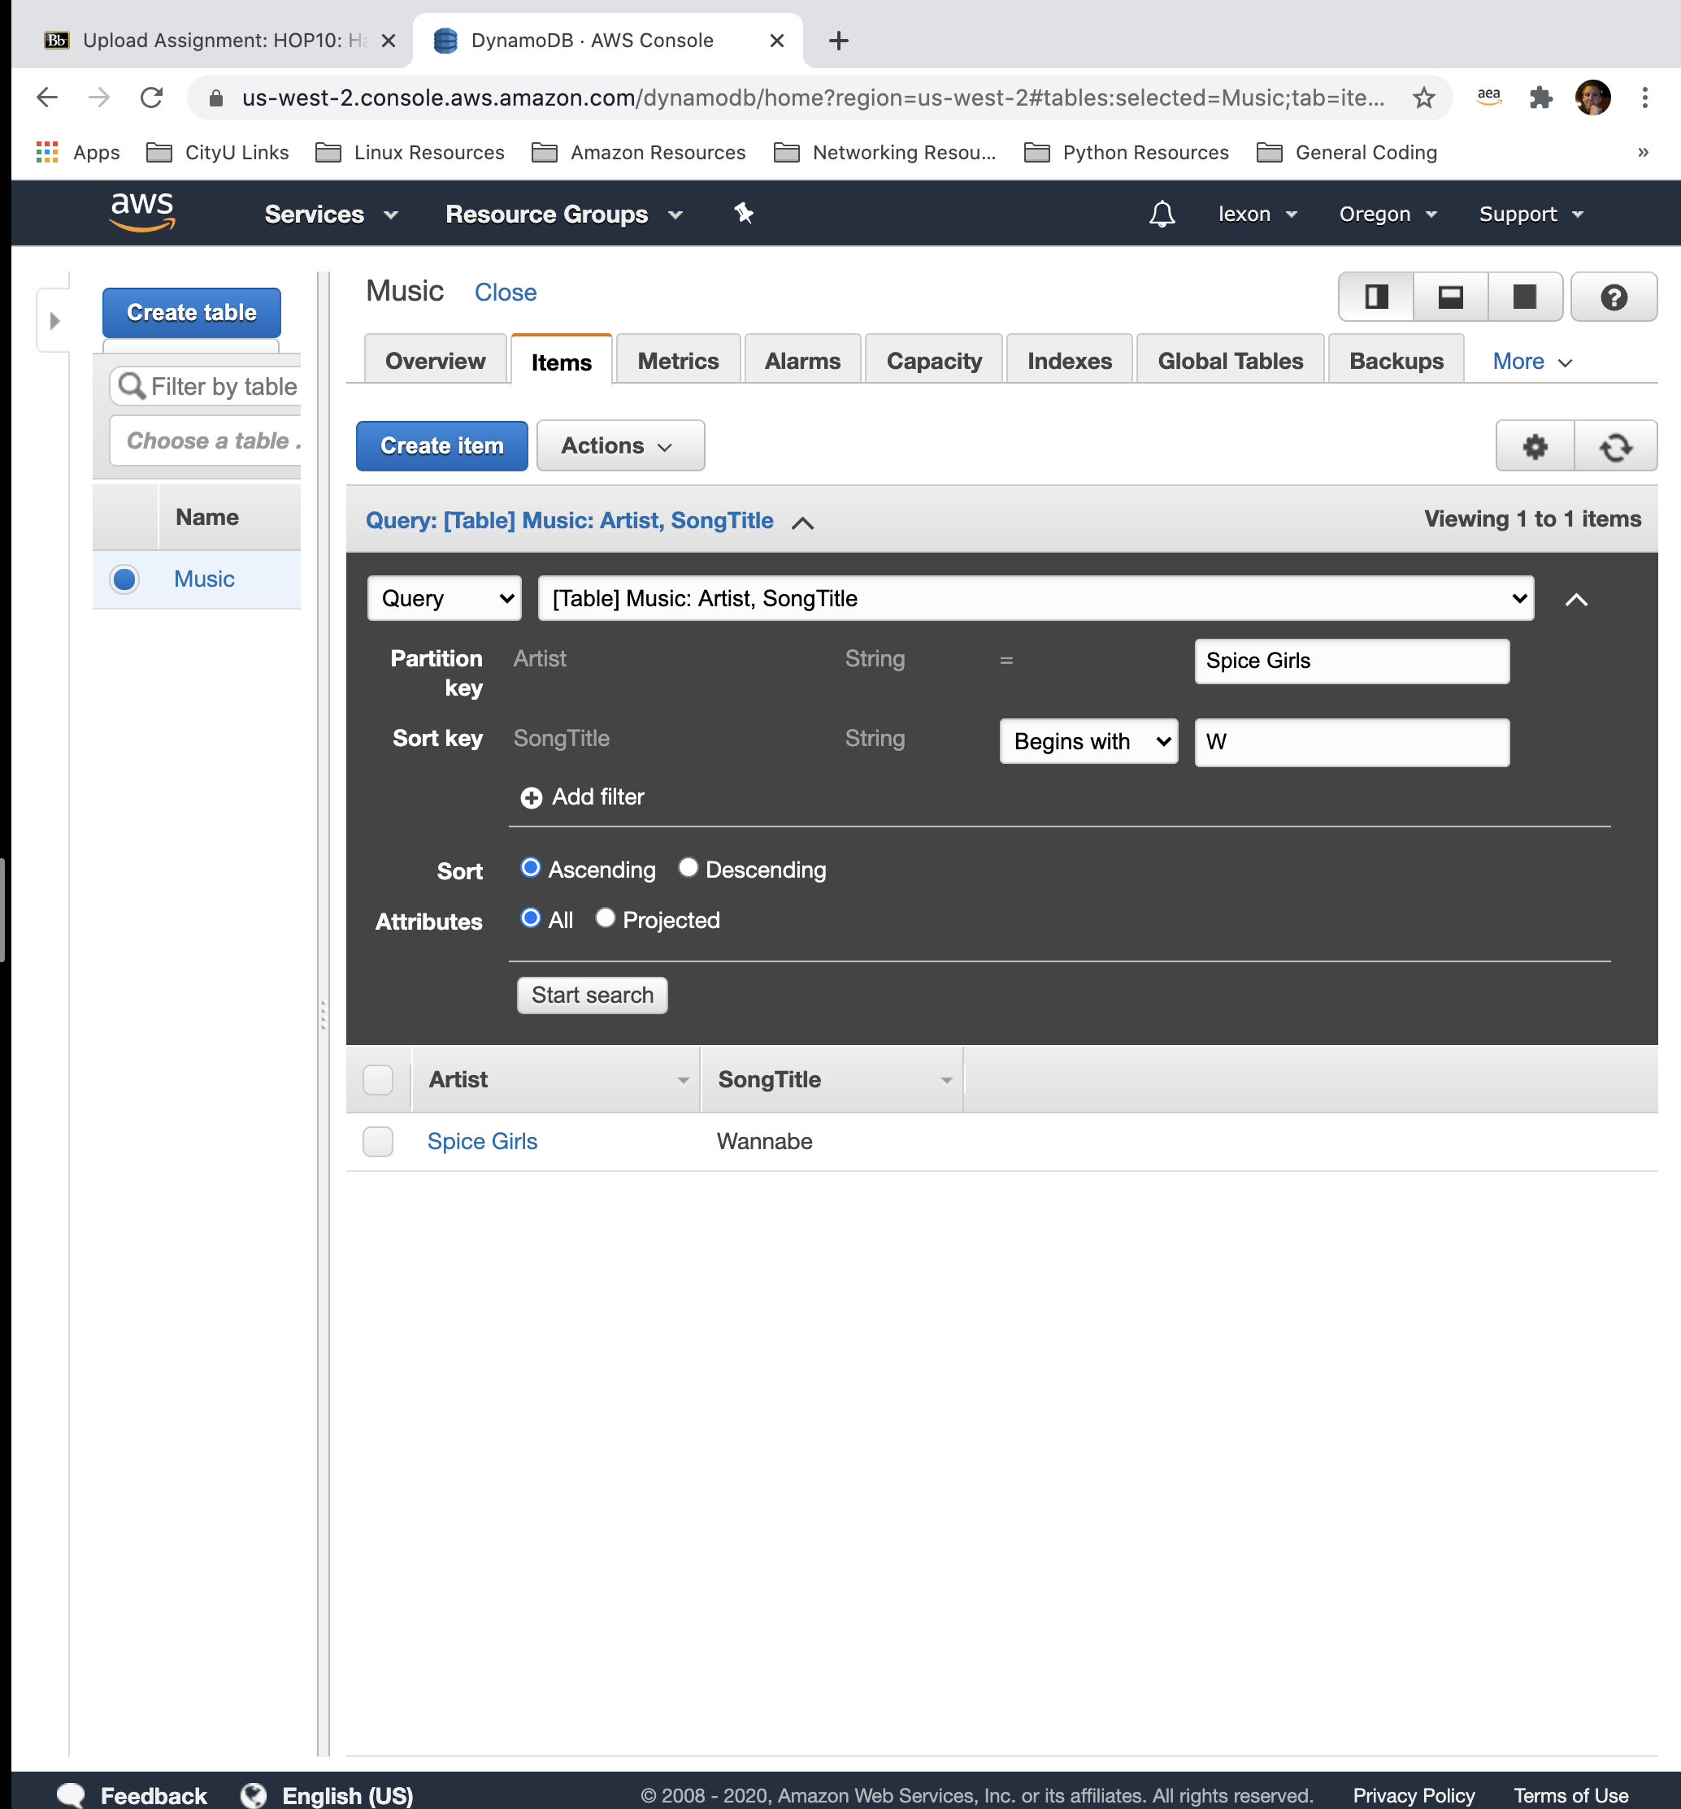

**PART 2**

This Hands-on Practice talked about querying and scanning a repository in DynamoDB.

The first the HOP had us do is to input a bunch of different artists and their respective songs into the repository.

After entering the data in, you can navigate to the top of the page to scan your data and filter the results that are returned based on some basic Boolean criteria.

The criteria starts with an Attribute, in this case, the SongTitle. Then you can choose the data type, in this case ‘string’. Then you have a choice of Boolean operators like =, <=, >=, contains, begins with, and more. Finally you enter the value to be compared.

In addition to scanning, you can build an actual Query for your database, which would be incredibly powerful in a database of millions of datapoints and values.

The Query option operates a lot like the filter with the same Boolean operators, with some added robustness in the specificity of your desired return.